WYOMISSING AREA HIGH SCHOOL



COLLEGE APPLICATION GUIDEBOOK

**TABLE OF CONTENTS**

To Do Immediately 1

Senior Year Timeline 2

Deadlines and Types of Application 3

Four Components of a College Application 4

Starting the Student Application 5

Submitting Standardized Test Scores 6

Requesting Teacher Letters of Recommendation 7

Requesting Transcripts and Counselor Documents 8

College Athletics 10

Financial Aid Terms and Processes 11

**TO DO IMMEDIATELY**

**By the end of the first week of school:**

1. Return blue FERPA card (received in homeroom on the first day of school) to Mrs. Gockley. TRANSCRIPTS AND LETTERS OF RECOMMENDATION WILL NOT BE SENT UNTIL THIS IS RECEIVED!
2. Check senior schedule for accuracy and ensure that you will meet all graduation requirements. ENSURING THAT GRADUATION REQUIREMENTS ARE MET IS THE RESPONSBILITY OF THE STUDENT.
3. Return “Student Self-Evaluation” and “Parent Input Form” that were part of the Junior Interview folder. COUNSELOR LETTERS OF REC WILL NOT BE WRITTEN UNTIL THESE ARE RETURNED.

**By the end of the second week of school:**

1. Make a Senior Conference appointment (if you did not have an appointment in August to discuss your post-secondary plan).
2. Schedule to attend a College Application Jumpstart session (if you did not attend a College Application Workshop this summer).
3. Register for College Rep visits on Naviance (plan to check weekly for an updated list).

**SENIOR YEAR TIMELINE**

|  |  |
| --- | --- |
| **AUGUST** | * Review your course schedule. Is it rigorous? Senior year is not a year to take a break. * Continue with college visits & refine final list of colleges (4-8 schools); Is the list balanced? * Brainstorm college essay topics * Finalize resume * Aug.1st-Sept. 1st- Applications open online – Begin applications * STUDENTS: Attend a College Application Workshop * Register for fall SAT & ACT tests (August through November) * PARENTS – Senior Parent Night mid-August |
| **SEPTEMBER** | * Schedule Senior Conference appointment * Attend an Application Jumpstart if you did not attend an Application Workshop in August * Begin applications if not yet started. Know the deadlines! * Touch base with teachers who are writing letters of recommendation. * College representative visits begin in Counseling Office and continue through November – Sign up on Naviance to attend. * Continue college visits. (through fall) * Begin looking at scholarship opportunities. (Naviance) * Submit Rolling Admission applications ASAP. |
| **OCTOBER** | * College Fair at Albright College (evening) – open to parents and students * Begin filing for financial aid – FAFSA – Opens online October 1st- Submit PHEAA forms after filing FAFSA. * Attend Financial Aid Night at Wyomissing * FAFSA Completion Sessions at Wyomissing * Submit Rolling Admission applications by end of the month if not already completed. * Request official test scores sent to colleges (via College Board and ACT) if not already completed. |
| **NOVEMBER** | * Early Action/Early Decision deadlines! * Continue applications & scholarships. |
| **DECEMBER** | * Make sure all Regular Decision transcript requests are completed by mid-December. * Thank you notes to teachers who wrote letters of recommendation. |
| **JANUARY** | * Regular decision deadlines! * Avoid senioritis! Many colleges will ask for 1st semester senior grades. |
| **FEBRUARY-APRIL** | * Continue to look for scholarships. Many scholarship applications are due during this time frame. * Update your counselor about college acceptances. * Review Financial Aid packages sent by colleges. |
| **MAY** | * May 1st- Deposit deadline at most schools! * Request final senior year transcript be sent to college. (Will be done in English classes with counselors) * Follow through with college requests to complete orientations, placement testing, and any required paperwork for Federal Loans – pay close attention to e-mails and online college portals to avoid missing deadlines. |

**COLLEGE DEADLINES AND TYPES OF APPLICATIONS**

**When’s the Deadline?**

**Rolling Admission** - No deadline so the earlier the better; applications open between August 1st-September 1st; Applicants are notified within 4-6 weeks of acceptance. Note that most schools do not notify students prior to mid-October.

**Early Action** – Definitive deadline usually between November 1st-November 15th (some colleges use October 15th and others are as late as December 1st so always check the specific college); no advantage for early submission; non-binding; decisions released mid-December

**Early Decision**- Definitive deadline usually between November 1st-November 15th (again always check the specific school) no advantage for early submission; decisions released mid-December; **BINDING – If accepted, you must attend!**

**Regular Decision-** Definite deadline between January 1st-February 1st (deadlines can vary by a month to six weeks – always check the specific school); no advantage for applying early; will hear of acceptance in mid-late March

**Priority**- Typically rolling admission schools which guarantee a response by a certain date if received by a certain date; typically exists at large, public rolling admission schools

**Restrictive Early Action**- Usually private college that only allows you to apply early action to one private college; Students can still apply early action to public colleges and rolling admissions schools

**How do I apply?**

**Common Application** – Group of approximately 800 colleges that all use the same application system (Commonapp.org); fill in the base part of the application & a common essay one time; Some colleges require extra pieces as well (called supplements)

**Coalition Application**- Group of 140 colleges (some also on Common App) that use the same application system; coalitionforcollegeaccess.org

**PASSHE Application**- Common application system for the PA State System Schools (Millersville, Kutztown, Shippensburg, Bloomsburg, Edinboro, East Stroudsburg, Indiana University of PA, Clarion, Cheyney, West Chester, Lock Haven, Slippery Rock, Mansfield); passhe.edu

**School Application** – found under the admission tab of the college website

**VIP Application**- Often mailed or e-mailed by the college directly to you for a particular reason (visit, special demographic, etc.); often waives the application fee

**MAY 1ST**

**DEPOSIT DEADLINE AT ALMOST ALL COLLEGES AND UNIVERSITIES**

**FOUR COMPONENTS OF A COLLEGE APPLICATION**

1. Student’s Application – includes application and essay (or personal statement) and supplements
2. Standardized Testing
3. Transcript and Counselor Documents
4. Teacher Letters of Recommendation

* Students are responsible for initiating all of the required components.
* Communication is key – Counselors and teachers do not know where to send transcripts and letters of recommendation without the student communicating that information.
* Please note that Naviance does not notify the counselor or the teacher when a student adds a school – the student must communicate that information to the teacher and counselor in a timely manner via a face-to-face meeting or by e-mail.

**STUDENT’S APPLICATION**

* Create accounts on commonapp.org or specific school websites; Use the “Colleges I’m Thinking About List” or “Colleges I’m Applying to” to help organize the type of application. (See requesting counselor letters for more information about using these lists.)
* Some colleges give the option of choosing between several different application platforms. When given the choice, we recommend choosing Common App.
* Work with English teacher on essay, personal statement, and/or supplements.
* Fee Waivers: Students who qualify for Free & Reduced Lunch should speak with their counselor about waiving application fees.
* Most applications require you to list senior year courses
* **Any change made to senior year courses will require that we resend a transcript with a student’s written explanation of the change. Your acceptance to a college is conditional. Changes made to the coursework or unsatisfactory senior year grades give colleges the right to reverse an initial decision.**
* **Disciplinary History:** Most college applications require that students report any suspensions or expulsions. The counselor is also required to answer this question when submitting your transcript and corresponding forms. The counselors are required to report any Out of School Suspensions. Please work closely with your counselor if you have Disciplinary History to report.

**IMPORTANT INFO FOR APPLICATIONS**

|  |  |  |
| --- | --- | --- |
| High School Address | 630 Evans Avenue  Wyomissing, PA 19610 |  |
| High School CEEB Code | 395-410 |  |
| Graduation Date | June 7, 2019 |  |
| Graduating Class Size | 157 |  |
| **Counselor Name:**  Kim Lally  Dana Quinlivan | **Counselor E-mail:**  [klally@wyoarea.org](mailto:klally@wyoarea.org)  [dquinlivan@wyoarea.org](mailto:dquinlivan@wyoarea.org) | **Counselor Phone:**  610-374-0739 ext. 2139  610-374-0739 ext. 2129 |
| GPA Scale | 4.0 - Weighted | * CA Education Section |
| Rank | Exact – Weighted | *CA Education Section |
| Course Scheduling System | Semester | *CA Education Section |
| Course Credit Value | 1.0= Full year course  .5= Semester course  .25= Semester course that meets  3 out of 6 cycle days | *CA Education Section |

**SUBMITTING STANDARDIZED TEST SCORES**

* Colleges require that students submit standardized testing directly from collegeboard.org or act.org
* Wyomissing Area does not include test scores on the transcript.
* Colleges continue to advise that they prefer to see the whole score history rather than the score from one test day.
* Please note that there might be a fee attached to sending these scores. If you qualify for Free & Reduced lunch and/or the fee is a hardship, please see your counselor.
* **TO SEND SAT SCORES:** collegeboard.org
* **TO SEND ACT SCORES:** act.org
* Please allow 2-3 weeks for colleges to receive scores. This means that scores needed for Early Action/Early Decision deadlines typically need to be requested by mid-October. You can request that scores be sent prior to the score release date for October tests.

**REQUESTING TEACHER LETTERS OF RECOMMENDATION**

* Initial requests should have been made in person at the end of the junior year. If you did not do so, please speak directly with teacher recommenders in the first two weeks of the school year.
* Teachers require that your resume be complete on Naviance. Some teachers also require additional questionnaires. Please be courteous and professional by returning these promptly to teachers.
* A teacher’s primary responsibility is teaching. Give teachers 3-4 weeks notice prior to an application’s deadline. Teachers often complete letters on their own time.
* Inviting Teachers on Naviance:

1. Go to the “Colleges” home page.
2. In the “Apply to College” box click “Letters of Recommendation.”
3. Click “Add Request”
4. Select the teacher you are asking; Select “Choose Specific Colleges”; Pay close attention to how many letters of recommendation a school will accept when making the teacher requests; Write a note to the teacher (including your name thanking the teacher for writing the letter)
5. Follow-up with the teacher after the Naviance request to make sure that he/she received it and knows where and by when to send letters.

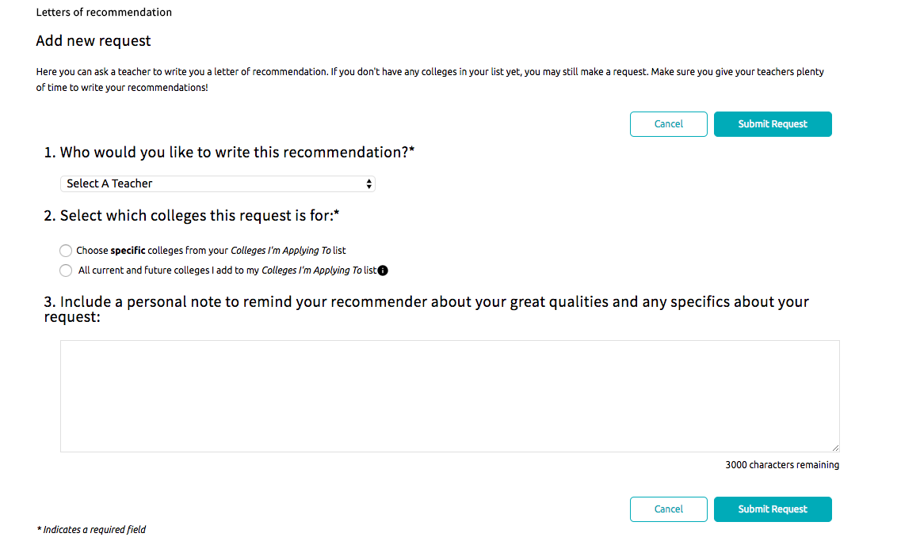

**REQUESTING TRANSCRIPTS AND COUNSELOR DOCUMENTS**

* All transcript/counselor letter requests must be made at least two weeks prior the application deadline. More advance notice is preferable during peak application time (October-December)
* The transcript request is not finished until **ALL** of the following steps have been completed.
* Most colleges require that counselors submit letters of recommendation and evaluation forms. Please note that counselors will not submit letters until students have returned the “Student Self-Evaluation” and the “Parent Input Questionnaire” that were part of the Junior Interview folder. Copies can be found in the Documents Library of Naviance.

**STEPS:**

1. On the “Colleges I’m Thinking About” page check all of the schools to which you are applying and click “Move to Application List”
2. Make sure to select the correct deadline and application type for each school
3. Click “Add and Request Transcripts”
4. Select “Initial Transcript”
5. **If applying to schools via Common App:** On the “Colleges I’m Applying to” page, click “Match Accounts.” Please note you must first sign the FERPA waiver in the Common App prior to being able to match. For help with matching, please link to the video entitled “Matching Common App” on the bottom of the Naviance Homepage. IGNORE THIS STEP IF YOU HAVE NO COMMON APP SCHOOLS.
6. **MOST IMPORTANT STEP**: Complete the transcript request card in the Counseling Office. Please see your counselor or Mrs. Gockley to do so. **TRANSCRIPTS WILL NOT BE SENT UNTIL THIS STEP IS COMPLETED.**

**THESE STEPS ARE REQUIRED EVERY TIME YOU ADD A SCHOOL TO NAVIANCE. NAVIANCE DOES NOT UPDATE COUNELORS WHEN NEW SCHOOLS ARE ADDED.**

**New%20transcript%20request%20form%20SAMPLE.pdf**

SAMPLE

**COLLEGE ATHLETICS**

* Students planning to participate in a Division I or Division II sport at the post-secondary level should register with the NCAA Clearinghouse – ncaaclearinghouse.org
* **Please request an initial transcript through Naviance under “Colleges I’m Applying To” and on the transcript request card in the Counseling Office**.
* Send SAT or ACT test scores directly to the NCAA Clearinghouse. NCAA does not accept test scores from Wyomissing Area.

**HOW WILL I PAY?**

**A BRIEF BREAKDOWN OF FINANCIAL AID AND SCHOLARSHIPS**

**Scholarships**

* Do not need to be paid back
* Private- WAEF; Community Scholarships; Fastweb.com; scholarship search on Naviance – require student to do research and complete scholarship applications
* Merit Scholarships- offered by colleges for students meeting certain academic requirements (usually GPA and test scores); typically, no application process needed – student automatically qualifies if he/she meets the requirements
* Performance based – athletic; performing arts, etc.

THE BULK OF SCHOLARSHIPS BECOME AVAILABLE FOR APPLICATION BETWEEN OCTOBER-MARCH OF SENIOR YEAR.

**FAFSA (Free Application for Federal Student Aid)**

* Parents/students must file application on fafsa.ed.gov beginning **October 1st** the academic year prior to enrollment; must be refiled yearly
* Types of aid that students/families can receive
  + Grants- money given to families (typically based on need or some special skill/characteristic); do not need to be repaid
  + Work-Study- part-time employment on campus for student as a way of earning money to pay for college costs
  + Loans – All students can qualify for a Federal Student Loan regardless of parental income; repayment typically starts 6 months after leaving college
    - Subsidized Loan – government pays interest on loan while student is enrolled in school (need-based)
    - Unsubsidized Loan- student is responsible for interest on loan even while enrolled in school
    - In the 2017-2018 school year, students qualified for the following amount of loan money:

Freshman Year - $5500 Sophomore Year - $6500

Junior Year & beyond - $7500

**PHEAA- Pennsylvania Higher Education Assistance Agency**

* Awards grant money to PA residents for attending PA schools (or a school in a reciprocal state) – need-based
* Complete after filing the FAFSA application -- **May 1st- deadline to apply**

**Private loans, etc.**- Need to be researched by the family/student; banks, credit unions, etc.

Please note that some schools – particularly private schools-- require completion of the CSS profile (<https://student.collegeboard.org/css-financial-aid-profile)> in addition to the FAFSA in order to get a complete financial picture.

**MRS. LALLY AND MRS. QUINLIVAN ENCOURAGE YOU TO WORK CLOSELY WITH THE FINANCIAL AID OFFICE AT YOUR INTENDED SCHOOL FOR SPECIFIC FINANCIAL AID QUESTIONS.**

**PLEASE PLAN TO ATTEND FINANCIAL AID NIGHT HELD IN EARLY OCTOBER TO LEARN MORE IN DEPTH INFORMATION.**

**FAFSA COMPLETION SESSIONS ARE HELD AT WYOMISSING AREA IN LATE OCTOBER.**